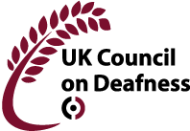

United Kingdom Council on Deafness
Conference 4th May 2023
Booking Sheet
Payment to Account no: 00010479
sort code: 40-52-40
or by cheque to
UKCoD, The White House Islet Road, Maidenhead, SL6 8LD
Members £10, non-members £20 or by special invitation
Please send booking sheet to info@ukcod.org
First Name
Surname
Email address
1st line of address
2nd line of address
Mobile/Telephone
Post code

