Deaf Awareness Week Website Sponsor
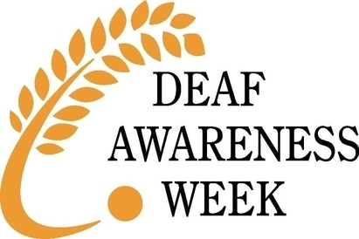

Thank you for supporting Deaf Awareness Week 2019!

Please indicate below your sponsorship package with an ‘x’

Sponsor Package 1
@ £1000
Sponsor Package 2
Please state number of Themes
@ £100 per theme
1 – 7 available

Please complete the details below where applicable and return this form to Clare Long at c.long@deafcouncil.org.uk

Contact Information - (Person authorizing sponsorship)
Name
Organisation
Address
Postcode
Work Phone
E-Mail Address

Please choose method of payment:
BACS
Cheque

Please provide invoice details here if different from above:
Name
Organisation
Address
Postcode
Purchase order No.
Your reference

Information to be displayed on the DAW website:
Organisation Name:
Logo (jpeg format)
Website address | http://www.

Thank you for completing this application form.
Once received we will acknowledge and gather any further details required.

Thank you!

